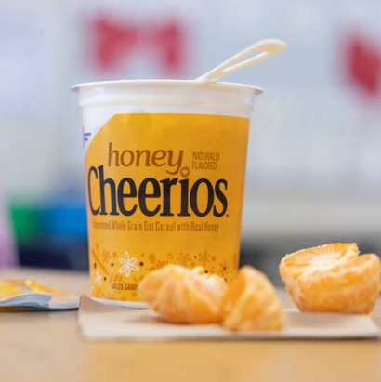
POST 1
Your student’s nutrition is a top priority. That’s why we offer their favorite cereals in low sugar,
whole-grain rich 2 oz. equivalent grain cereal cups!
*Several cereals are also available gluten free*

POST 2
Let your student(s) start their day the way they love… with a big nutritious cup of cereal! We have a variety of heart-healthy, low-sugar and even gluten free options available.

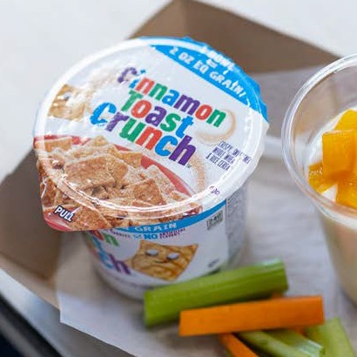
POST 3
Did you know our lineup of 2 oz. equivalent grain cereal cups provide at least 12 vitamins and
minerals? Kick start the morning with your favorite whole grain-rich cereal from General Mills!

